PROJECT DESIGN PHASE
Solution Architecture

Date | 2 November 2025
Team ID | NM2025TMID08137
Project Name | Educational Organisation Using ServiceNow
Maximum Marks | 4 Marks

Solution Architecture:
Goals of the Architecture:
- To build a centralized Educational Management System on the ServiceNow platform.
- To automate the admission process and manage student information efficiently.
- To integrate ServiceNow databases and workflow automation for real-time process updates.
- To provide secure data storage, analytics, and system monitoring for all educational operations.
- To deliver a user-friendly interface for students, faculty, parents, and administrators.

Key Components:
- Admission Table (u_admission): Handles student admission records and manages their status transitions — New → In Progress → Joined → Rejoined → Closed → Canceled.
- Integration Layer (ServiceNow IntegrationHub): Handles
communication between the Student/Parent interface and the ServiceNow database.

- ServiceNow Database (CMDB / Custom Tables): Stores all institutional data, including student, parent, and academic information.
- Analytics & Reporting: Generates reports for admissions, student progress, and system performance.
- Security & Monitoring Layer: Ensures data protection, user authentication, and system monitoring.
- Cloud Storage and Email Notifications: Sends alerts and admission updates automatically.

Development Phases:
- Initialize ServiceNow Instance – Configure the instance and set up the development environment.
- Create Custom Tables – Design the Admission Table and related data structures for students and faculty.
- Design Forms and Layouts – Develop intuitive and responsive interfaces for data entry and administration.
- Implement Workflows – Define automated flows for admissions, approvals, and data updates.
- Develop Client Scripts – Add dynamic form behaviors, field validations, and automation logic.
- Integrate Cloud & Email Services – Enable notification and alert functionalities for real-time updates.
- Apply Security Controls – Configure authentication, access permissions, and monitoring systems.
- Test and Deploy – Conduct thorough validation, fix issues, and ensure smooth data flow across modules.

Solution Architecture Description:

The Educational Organization Using ServiceNow architecture is designed to digitalize and streamline all academic and administrative processes within an institution. It brings together multiple layers—such as the Admission Module, Integration Layer, and ServiceNow Database—to deliver a unified and efficient digital environment.

Students and parents interact with the system through a simplified front-end interface, which communicates with the Integration Layer (IntegrationHub) to connect with the ServiceNow backend. The Admission Table tracks every stage of the admission process, ensuring data accuracy and transparency at each step.
All information is securely stored in the ServiceNow Database, supported by automated workflows that handle approvals, notifications, and updates. The system also integrates analytics dashboards to help administrators monitor institutional performance, and security layers to safeguard sensitive academic data.

Cloud storage and automated email updates enhance connectivity, ensuring that stakeholders receive timely information. Overall, the architecture supports automation, scalability, and transparency, enabling institutions to manage all academic and administrative workflows efficiently through a single, secure ServiceNow platform.

Example – Solution Architecture Diagram:
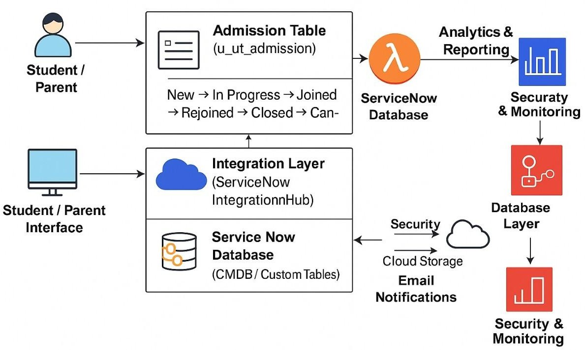
Figure 1: Architecture and data flow of the Educational Organisation Using ServiceNow application.

